Off-Shore: A Deconstruction of David Maclagan’s and David Mann’s ‘Inscape’ Papers

Sally Skaife

40 Gloucester Drive

Finsbury Park

London N4 2LN

Tel. 0208-809-3001

Email sally.skaife@btopenworld.com or s.skaife@gold.ac.uk

Abstract

This paper is a response to two recent papers in The International Journal of Art Therapy, Inscape that set out positions in relation to art therapy theory. David Maclagan (2005) argues for the importance of ‘imagination’ in art therapy, and David Mann (2006) responds by defending a Freudian view of art therapy which he feels Maclagan has unfairly attacked on the grounds of it suppressing imagination. The view of this paper is that the arguments in both papers perpetuate the split in art therapy between an emphasis either on the art in art therapy or the therapy in art therapy, and in both cases this is because the authors neglect the significance of embodiment. An acceptance of ourselves as physical beings brings with it an awareness of context and of gender and therefore of political relations. The two papers are deconstructed to reveal that the suppression of the perceptual results in a perpetuation of the crystallisation of imagination rather than the releasing of it, which the authors are intending. The feminist philosopher and psychoanalyst Luce Irigaray’s writings are used to propose a new way in which we might think about the relationship between art and talk in art therapy.

Word Count 7,039

Key words art therapy, theory, gender, deconstruction.

Biography

Sally Skaife is programme leader of the MA in Art Psychotherapy at Goldsmiths College and supervises students on research programmes in Art Psychotherapy. She continues her clinical work at the Medical Foundation for Victims of Torture and is completing a PhD on art therapy group theory. She was a member of the editorial board of Inscape for 20 years. She was co-editor of ‘Art Psychotherapy Groups: between Pictures and Words’, and has published numerous chapters in books and journal articles.

Introduction

This paper is a response to two recent papers in The International Journal of Art Therapy, Inscape that set out positions in relation to ‘imagination’ in art therapy theory. There is much that I would agree with in both papers but there are some fundamental assumptions which are deconstructed in this paper. I argue that together the papers perpetuate the split in art therapy that can be traced back to Naumberg and Kramer (Waller and Dalley 1992), between an emphasis either on the art in art therapy (Maclagan) or the therapy in art therapy (Mann). Maclagan appears to neglect an idea of therapeutic purpose or the therapeutic relationship, and Mann neglects attention to the particularity of art as a different language than talk. Both authors privilege the cerebral over the perceptual and sensual. These splits seems to be an example of the mind/ body, idea/ materiality division inherent in Western thinking which leads to a neglect of the centrality of a recognition of context to any meaning. Both authors appear to disregard: the context of the production of the one patient’s image that is spoken of; the significance of the male perspective of a debate between two male art therapists and their father figures, Jung and Freud; recent theorising about art therapy, for example, Schaverien 2000, Tipple 2003, Skaife 2001, despite assertions made about art therapists.

In this paper I will show how the body, materiality and art are placed in an inferior position to cognition in the Maclagan and Mann papers, and argue that this has political ramifications, in terms of class and gender. Eagleton (2003) talks about ideas being associated with the middle classes and sensuality with the working class in the dominant ideology of Western society. The proletariat are defined by materiality; the word prole means offspring and relates to the role of the working class in providing labour. Women use their bodies to give birth to and to provide for the physical needs of those that will use their bodies to labour. The middle classes meanwhile, having their physical needs more easily met, have the privilege of time to think about the meaning of life. This hierarchy, Eagleton says, is reflected in the amount of attention given to the cultural subject ‘Aesthetics’ in the last two centuries in comparison with that given to artists struggling to make art. The point is not to overturn this privileging of cognition over perceptual experience, but to deconstruct the split. I will argue that materiality, the body and art can be fore grounded in art therapy theory without the loss of a logical, cognitive understanding of the purpose and direction of therapy, not through a focus either on art productions, or imagination, or analysis of the relationship of the parts, but through an emphasis on the meanings involved in performance. That is, the various performances involved in art therapy: the setting up of the art therapy studio, making art work, showing the art work, talking about it, and so on.

I will first present the two papers by David Maclagan and David Mann, and will then, through drawing on the philosopher Jacques Derrida’s deconstructive method, attempt to show how the suppression of materiality leads to a neglect of context in the papers. This results not only in limiting the understanding of images, but also in a danger of creating splits in art therapy practice that may bring into question the need for a discreet profession – psychotherapists can use art, and art teachers open studios. I will then draw on the French philosopher and psychoanalyst, Luce Irigaray’s writing to show a feminist alternative to Maclagan and Mann’s ideas about the relationship of talk to images.

David Maclagan’s paper.

Maclagan argues that whilst fantasy and imagination are thought of as the hallmarks of art therapy this is often not reflected in the art therapy literature. Imagination, he thinks, has a key role in unlocking the ‘psychological lining’ of images, and he believes is central to all aspects of the art therapeutic encounter. Maclagan thinks that culturally we are saturated with images and that this leads to a ‘collective imaginative numbing’ (Maclagan 2005:24). Art galleries often privilege knowledge about the artist or genre and are too negative about subjective responses to art. He thinks imagination has been suppressed in art therapy because of its adherence to Freudian psychoanalytic theory which has fixed ideas about the unconscious, and interprets art ‘against the grain’. Jung’s active imagination in response to images is better, and he quotes Jung as saying that image and meaning are identical. Post-Jungians, rather than regard images in terms of cognitively prescribed symbols, allow images to speak for themselves, and words in response to them to act equally as images. Maclagan also blames the pressures at large in the public sector – cost-efficiency, auditing and evidence-based practice, as militating against imaginative responses to the patient and their art work. He also cites popular notions of a fit between intentions and resulting image, as prohibiting patients using their imaginations.

Maclagan promotes an awareness of all the senses in relation to the art therapy setting and the different activities involved in art therapy. He thinks that psychoanalytic language is too cognitive, and a more figurative language is needed. Maclagan describes three stages in addressing an image: description, elaboration and interpretation. Description requires an interrelationship between the aesthetic quality of the image and its psychological resonance; elaboration is a sort of play with the metaphors of the image; lastly under ‘interpretation’, he returns to the idea of the image reflecting the patient’s pathology or that it may alternatively be understood through the collective psyche. He argues against seeing the image purely as part of the painter’s psyche and suggests that an archetypal perspective helps get away from this to a more collective understanding of imagery. His argument can be summed up in his concluding thoughts. ‘It is not putting images into words that amounts to some kind of betrayal; it is the use of an imageless language, a theoretical or conceptual vocabulary’ (Maclagan 2005:29).

David Mann’s response
David Mann describes his paper as re-imagining a psychoanalytic perspective for art therapy. His paper then does this whilst critiquing the ideas in Maclagan’s paper. He starts by stressing the importance of an autobiographical approach to art work, and thinks that recognising that the patient has problems is not pathologising in the sense that Maclagan is saying. He describes the essence of the difficulty for art therapists as being what they should say or not say to patients. He recognises that whatever is said in response to an art work is inadequate, but is equally against saying nothing. He thinks that even as a base line a conversation is necessary to know if a patient’s art making has been integrative. He says that we cannot help but be imaginative but this does not necessarily help with problems. Imagination gets compounded with the patients’ symptoms and defences. These restrictions have originated in childhood and need working through if the patient’s imagination is to be freed. The Freudian model he espouses maintains that through the patient expressing thoughts and fantasies in the therapeutic situation, the obstacles to his using his imagination become apparent and are also reflected in the therapeutic relationship. This helps expose the powerful sexual and aggressive influences in the mind. Free association, a fundamental tool of psychoanalysis, is pure imagination, he says.

‘A potentially unique therapeutic opportunity is offered if the art therapist accepts that the way in which the art is made, the patient’s relationship to the art work and his or her relationship to the therapist all reflect the patient’s hopes and anxieties’ (Mann 2006:35). Mann thinks that Maclagan’s responses to the patients in therapy are no different than what is incorporated in psychoanalytic thinking. Mann is in agreement with Maclagan that imagination is not given the status it deserves in art therapy but he thinks that a psychoanalytic model of art therapy is the way in which this can be rectified. He ends by saying that art therapy needs more psychoanalytic influence not less.

Deconstruction
I have approached these texts through a deconstructive method which put very simply, relies on the following: our need for certainty means that we suppress what does not fit; we tend to make binaries privileging one side of the pair over the other, for example, order/chaos, mind/body. Derrida’s thinking is that in texts, the thing that is suppressed lingers around upsetting the meaning of the argument. We cannot avoid writing in this way as it is the history of the way in which thinking has developed. Deconstruction, though, is a means of revealing those things that are repressed but still suggested in the text, and the purpose of this is not just to be critical but to expand our understanding, deconstruction is a never ending process. Deconstruction has a lot of similarity with psychoanalysis, and with Maclagan’s idea of elaboration in relation to an image which is also a way in which Derrida himself approaches texts. As Melville says:

‘Deconstruction presents itself as, in general, a practice of reading, a way of picking things up against their own grain, or at their margins, in order to show something about how they are structured by the very things they act to exclude from themselves, and so more or less subtly to displace the structure within which such exclusions seem plausible or necessary. Like an analyst listening to an analysand, deconstruction tends to the other that haunts, organizes and disorganizes, a speech that takes itself to be in control of its meanings and identity.’ (Melville 1990 in Preziosi 1998:401)

Unlike psychoanalysis, deconstruction does not consider what was previously hidden to belong to an interior world or to have greater significance than what is already revealed.

Critique

Whilst I agree with both Mann and Maclagan that it is important to keep in touch with imagination and fantasy and to stand up to the ever more insistent demand to turn everything into a deadening cognitive language, I take issue with Maclagan’s claim that imagination is ‘primary’.

Overturning the hierarchy between the cognitive and the imaginative simply perpetuates the split, and leaves art therapy in a situation of flights of fantasy which have no clear relationship to the purpose of the therapeutic endeavour, which surely must involve interpersonal relationships. Mann comments, appropriately in my view, that Maclagan is talking about imagination as if it were a separate bit of the mind from other bits. In this he separates imagination off from perception leaving it cut off from the body. Mann, though working with interpersonal relationships within the psychoanalytic frame, similarly privileges the cerebral; he regards conversation in an attempt to understand, to be the desired end result of therapy and misses out anything about the process of making in art therapy. Thus both authors privilege the mind and neglect the body and perception, a split that has arisen in Western thinking since Descartes separated the mind from what the mind thinks about.

This split is reflected, to my mind, in the distinction Maclagan makes between the psyche and the aesthetic. Though in places he discusses the psyche and the aesthetic as having an intertwined relationship, describing the art work as having a psychological lining, in other places he clearly regards the psyche as a separate subject viewing the aesthetic object. In describing ‘psyche’ as archetypal he detaches it from any physical manifestation. It is a free floating collective mind.

As Mann says, the test of any theory is in the clinical examples: ‘do they have meaning in clinical practice?’ (Mann 2006:36) We will now look in particular at the one image made by a patient that is discussed in the papers. This is chosen in order to explore further how materiality in art therapy clinical practice is placed in each theoretical position. We will consider the image as it appears in the journal article and then how it appeared in the therapy group in the therapeutic community.

The ‘Fence’ Image

This image, (fig.1) we are told, is produced by a woman with intractable obsessional routines in a group session in a therapeutic community. There was a theme – ‘draw yourself as an island’. Maclagan describes the picture, and as he has said earlier, such a description immediately leads us into a figurative language, ‘we can see straightaway where the greatest formal concentration of energy is: in the emphatic repetition of the black ‘fence’ that defines and protects her ‘territory’. So much has been invested in this defence that all that is left inside are a couple of sparse lines of grass. The image provides a cruelly apt metaphor for her psychological state. This leads us straight into elaboration.’ (Maclagan 2005:27). But then, as Mann points out there isn’t any elaboration of this image. In fact Maclagan has done exactly what he has been arguing against; he has pushed the image back into the patient’s autobiography which he has here defined only as pathological. Though this is in keeping with his own argument, Mann also goes for the same meaning to the metaphor without question, saying that Maclagan has got it right. Mann goes on to illustrate how he might work verbally with images, giving some possible interpretations of the image – ‘That fence you have painted looks very high and sharp to keep you in or intruders out. I wonder if that is also protecting you here as you paint and perhaps a need to defend yourself in therapy’ (Mann 2006:37).

In these responses to the image both Mann and Maclagan treat the image as though it originates solely inside the woman who has painted it. There is no idea of a history to the image, to the situation that prompted the image or to a social arena in which it was either experienced at the time of making, or in its context in the journal. A closer look at the reproduction of the image in the journal shows that it has no top edge and that the side edges have been cut off, presumably for ease of publication. Thus we cannot be certain that the image is portrait shape or landscape shape, whether we look up at a fence or down at what, a mouth? In introducing the image, Maclagan directs us to the inside front cover to explain the context in which the image was made. Here there is a description of the image on the front cover (fig.2) made by the therapist also at the community in what sounds like the same series of group sessions. It is a figure inside the mouth of a whale, and the sharp white teeth defined in heavy black, bear an interesting similarity to the black ‘fence’ in the patient’s painting.
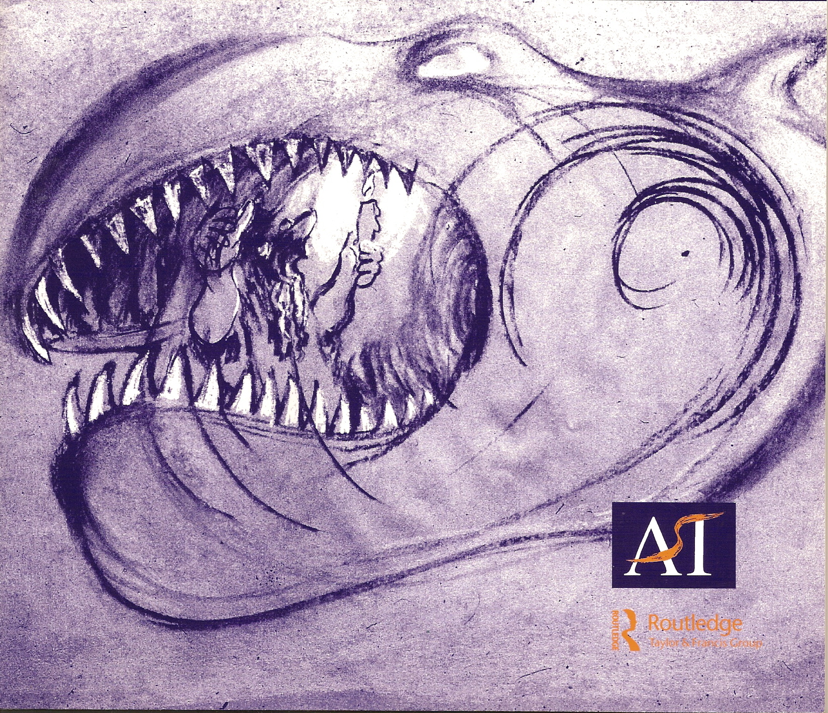

Figure 1 Figure 2

These are the relations of the image in the pages of the journal but what was its constellation of relations in the group? The group have been asked to make a self-portrait – this certainly aids the accuracy of an interpretation – but specifically, the self as ‘an island’. What does this request mean in the context of a group? They are asked to consider themselves as isolate and separate from one another, to cut themselves off (and now I see a ‘saw’) from one another, the ‘fence’ that keeps things out or protects them inside then, has come from the therapist’s suggestion and thus belongs as much to the therapist as to the artist/patient. The intention of the papers, however, appears to be to regard the image as an isolate, a reflection of the artist/patient’s insides or of an isolated archetype whose meaning holds still across time and cultures. The attempt seems not to use imaginative variation but actually the opposite, to pin the image down to one meaning, to be at one with itself, to be an island. The effect of this, to my mind, is to keep the patient as a patient, to enclose her within herself.

It is important for the patient that the image is recognised as reaching beyond her, just as artists hope their work will speak without them there to explain it. This will help the patient engage and connect with the world rather than keeping her an island. Archetypes and the universal and timeless collective unconscious cannot serve this function as they are impersonal and not rooted in time and place. Derrida’s concept of ‘iterability’ which is what deconstruction reveals, can help here. Iterability means that the mark’s meaning must have the potential to be repeated otherwise it could not be known. If this is so, then the meaning of the image must have some sort of life outside its producer and its audience. This presents some sort of contradiction with an understanding that the image only can be understood in the circumstances of its production and in the context of its being received. Of course the ‘fence’ image would be understood differently if it had been a marking on a shield in 19th century Africa, or if it had been made in response to a different theme – a child asked to draw a headdress. However, writing, Derrida insists, and we could replace drawing for writing, must remain readable without a reader.

‘In order for my ‘written communication’ to retain its function as writing, i.e. its readability, it must remain readable despite the absolute disappearance of any receiver…. My communication must be repeatable – iterable – in the absolute absence of the receiver or of any empirically determinable collectivity of receivers. Such iterability – (iter, meaning ‘again’, probably comes from itara, ‘other’ in Sanskrit, and everything that follows can be read as the working out of the logic that ties repetition to alterity) structures the mark of writing itself, no matter what particular type of writing is involved.(Derrida 1988)

What Derrida is saying is that there wouldn’t be such a thing as writing unless the marks had already been made somewhere and acquired a meaning that suggested something other than what is there in the present moment. They also must be able to be repeated at another time that has not yet happened. Therefore, within the present meaning must also be past meanings and potential future meanings and therefore something other than what is now meant.

An island implies a pure presence, a discrete present moment of consciousness, separate from other moments, from other beings. It is this that comes to be regarded as acceptable truth: for example, that the picture represents the patient’s fears, that an ‘image is psyche’, that a conversation confirms integration. However, if presence is always tainted by traces of what has gone before, of the image in previous contexts that cling to it imperceptibly, then there can never be a single, static meaning. The traits of the image refer to things not necessarily noticeable at first glance at the image.

What became hidden then in the way that this image was looked at? The opposite of the island – the community, is left out. The community of the group, whose influence on the appearance of the image and its making are hidden, as is their reflections on its meaning in the group space. Also missing in the paper is the community of art therapists exploring these same ideas. The image now looks like a line of figures in a community, a group of penguins perhaps huddled together for warmth.

Exploring the image as a physical object revealed its missing relations to the words that had preceded it, to the viewers that had received it, and its place in this article. It seems that words and image came together in the example as a package – the island, the self-portrait and then the image. The image then existed between the performance of the therapist and the patient and the hidden group. In the context of a therapy group imaginative exploration that acknowledges the materiality of the image, its connection to the visible world, as well as the artist, the group and the therapist, allows the patient to experience themselves imaginatively, and to see themselves from different perspectives. This contrasts with seeing the image either purely autobiographically as I think David Mann is arguing, or in the split between a pathologised artist/patient and a universal archetype as, in places, Maclagan appears to be arguing.

I will now give an example from the clinical practice of one of my supervisees to illustrate an alternative way of thinking about an image from one whose origin is solely inside the artist. The example focuses on the intersubjective relationship of materiality inherent in the art therapeutic encounter.

Clinical Vignette

Pam (a pseudonym) belongs to an art therapy group which takes place in a social services mental health day centre. She is one of the founder members of the all-women group which has run for about 18 months. The group currently has five members. Until the last few months the group has had very sporadic attendance with usually only two or three members attending. All group members have fairly long histories of psychiatric conditions; most having had some short, psychotic episodes as is the case with Pam. Pam’s present concerns are her phobias about going out, and her oppression by a violent husband and demanding father. In all the relationships she describes, she appears to be fearful and distant.

Pam has only made one artifact since she has been in the group, though recently she has started another similar one. This is not the actual picture but one made by me in memory of the original.

This primary work is an A3 sheet of white cartridge paper which she has divided on each side into 16 rectangular ‘portrait’ sections, by folding the paper. At the top of each section is written in small writing, the date. Then each section is filled in differently, but always using pencil and crayon and always with a line or dot repetitive decoration. The main effect is of grey pencil marks with some bits of faded colour. Because this work is taken out each week for a new space to be filled in, the paper itself has become very thin, crisp and fragile. The artist does not give it meaning and neither do the group. She is shy and secretive about her work, as if she is ashamed of it. The rest of the group also seem to feel uncomfortable about it, and often encourage her to branch out and take more risks with her art-making. However, other members of the group do quite similar work, usually abstract, often without focus, though rarely if ever carrying on on the same piece of paper for more than one week, which seems to have become the main meaningful feature of this piece.

Pam’s image could be understood as showing up form and as minimising content, similarly to many artists particularly of the 1960s and 1970s. However, if looked at autobiographically this image could be understood as one that Mann would see as blocked imagination, uncreative and thus a manifestation of a defence. I am being presumptuous here as I actually found this piece of art work striking when the therapist brought it to supervision along with the work of the rest of the group. I think it was because in one way it was so minimal, but in another the fact that the same piece of paper was worked on each week, made it seem very powerful.

Let us now explore the materiality of the image. Pam’s use of materials is minimal: she has used only a pencil point and paper, like an index finger perhaps and skin ageing over time. The filling in of the squares makes me think of handwriting exercises done in school, or knitting. These associations are culturally determined, for example, traditionally speaking one might associate knitting with women, perhaps working class women, and handwriting exercises, with children. These are the art forms that Pam appears to be drawing on to create her own art and they show up something about a particular position in society. Looked at autobiographically, perhaps the talk of oppression by the men in her life is related to this. By using the same piece of paper each week, which nobody else in the group does, a statement is being made. She records that she has come to the group and is participating in it. But each square is filled in with only the minimum of difference. How does this relate to the expectations of the situation? Regular attendance is an expectation, and this she in a sense comments on by dating the sections. Another expectation of the group, as said by the members, is that she should take risks, is this in order to reveal things, or to change, or to make her art work more interesting? Interestingly this is clearly resisted. Perhaps then her picture could be seen as a political statement referring to the power differentials involved in the institutional provision of art therapy.

Despite her picture, in a sense, giving off a message of no change, or resistance, the skin/paper has its own message as it is becoming very fragile and will eventually disintegrate. As the picture is presented each week to the rest of the group as they sit round to look at what they have done, this aspect of the work becomes integral to its meaning. A dynamic about change is created. The world goes on and everything eventually comes to dust, whatever one does or does not do. However, we have a relationship to the demise of all things including ourselves, and so are faced with choices. Into the group, in the materiality of this piece of work, come existential issues about the world, and the choices we have in it.

I have attempted to show a way of looking at the image which focuses on the materiality of what is produced, rather than the client’s inner world. Neither political statement nor a dynamic about change may have been Pam’s conscious intention, and I think it would be a mistake to focus on whether or not they were unconsciously intended. Instead, issues relevant to everyone in the group were brought into it by this picture, and these would mean different things to each person depending on where they stood. The particularity of the art work, to use Eagleton’s word, is meaningful, subversive even, when understood as having agency in a boundaried social situation.

If the art therapist thinks of what the work says as opposed to what the artist/patient says, she will get to something that also feels outside of the person too. If we feel that making art is not in our control, then we need to feel that others recognise the art as having a life of its own too. Focusing on the materiality of the art work revealed something about its life that was separate from the group itself whilst the meaning of this also belonged to its life in the group. Thus there is a space for movement between the individual and the group, the individual and group and the world beyond and behind. The image belonging in-between all these spaces allows the patient to move out of themselves into and around others and the world and back into themselves in a reconstituted fashion.

Talking in art therapy

Mann says that the ‘essence of the difficulty of being an art therapist is this: when the art therapist speaks what does she or he say to the patient?’ How should we think about the relation of words to art in art therapy? Is it enough to play with the image imaginatively as Maclagan claims, or is the talk essential either for processing the multiple meanings arising from the image, or to know there has been integration, as Mann believes?

Maclagan appears to want to avoid interpreting art work, and suggests picking up on the narrative of the image, or using figurative language to describe its character. These ideas seem good ways of opening up the image. However, like the impossibility of avoiding imagination, we cannot help but interpret, though it is obviously important we do not impose our own interpretation on the client inappropriately as Mann says. I am in agreement with Mann that simply opening the image to imaginative play is not enough because without a meaningful context it does not address how art therapy is going to help the client with why they have come into therapy.

However, I do not agree with the implications about verbalisation that Mann suggests in asserting
‘It is not possible to know what the painting means to the artist or how the artist is using it unless there is a conversation’( Mann 2006 p.34 ) To me this is an assumption that integration can be recognised better in words than it can through looking at the art work. It is useful to consider that the symptom is after all, a performance or bodily enactment of a problem. The woman who painted the fence spent four hours making herself physically presentable to other people. It was how she looked to others that was the meaning of the symptom. Without greater acknowledgement of the significance of embodiment in relationships there is a danger that art ends up just a springboard for talk. This seems an acceptance of the superiority of mind and logic over body and perception.

What have other art therapists said about the subject? Schaverien’s analytical art psychotherapy attempts to promote the perceptual in its notion of art as transformational through its embodiment of the transference relationship. Any discussion would revolve around this. For Dalley (Dalley, Rifkind and Terry 1993) it is play involving both the imagination and the perceptual, and talk would be related to this. My own view is that while these theories incorporate the image, the making of the image and the therapeutic relationship in a coherent whole which then gives shape to the discussion, the tensions in the relationship of talk to art are not addressed. For example, talking (when the visual is not suppressed as in ‘on the couch’ psychoanalysis) involves looking at the face of the person one is talking with, whereas exploring the art work involves looking away from people. These tensions may be much more apparent in group work with adults. A focus on the images in a group, takes time away from interpersonal exploration and vice versa. McNeilly (2006) advises structuring the group, but this takes the whole question of language and its meaning out of the material of the group as well as fixing the power relations over activity in the group. However, if there is no fixed structure and the difficulties that arise from the tensions are not incorporated into the art therapy theory, logical language is likely to get the upper hand particularly when patients are capable of verbal reflection. This is maybe why Maclagan still feels the need to focus on the importance of fantasy and imagination in art therapy, feeling that it has been insufficiently addressed in the art therapy literature. As important in my view, is the potential productiveness that is to be found in the way in which art and talk differ.

There is a complication with these distinctions, though, as they could be understood as upholding fixed binaries. How do we define art as different from talk in order to promote it in art therapy without falling into the same trap which is responsible for privileging logical discourse over perceptual activity? This paradox is taken up by Irigaray whose resolution to the dilemma is to have two aims: to promote the feminine or perception and at the same time to consider ‘the couple’ or the relation between the cognitive and the perceptual, as how they are now, in this period of history and space, that is as separated and hierarchical.

Similarly to Irigaray, Eagleton talks of the relationship between aesthetic discourse and the particular art object. He describes the main purpose of aesthetic discourse, which developed following the Enlightenment in tandem with the growth of art as a commodity, as a bourgeois enterprise which provides the middle classes with an escape from the pressures of living in the competitive, market driven modern world. However, it has value in that it retains something of what it describes, a ‘charge of irreducible particularity, providing us with a kind of paradigm of what a non-alienated mode of cognition might look like’ (Eagleton 1990:2).

Art therapists, then , should not just seek to overturn the privileging of a logical language, but to keep the difference, not allowing talk, for example interpretations according to single meanings, to dominate, but enter into a space where difference is acknowledged, and its potential for fecundity realized. Irigaray talks of this space happening in a silence.

‘The space between the two will be kept by silence, a silence which does not amount to a lack of words but to a safeguard of a place which belongs neither to the one nor to the other, which is neither proper to each one nor common to the two. This silence maintains the possibility of entering in to presence as two, two different, and of talking together a language which is neither already defined nor the same for each one.’ (Irigaray 2004, pxiii)

Irigaray says that the emphasis in psychoanalysis on turning sensory experience into language not only does not deal with the problems that are caused by such a logic, but can make them worse. Her description of imagination is psychoanalytic, similar to that of Mann’s, but she includes the relationship of sensuality to it: ‘The imagination produces symptoms, it is one of the causes of the unconscious, or else it creates a body of work and an identity: the one thanks to the other. The imagination forms a seed around which the past- or its past- crystallizes, or else it opens to a future. All this requires there be a present. This present, in my view, is bound up with perception, perceptions, and with the act of creating.’ (Irigaray 2004:119)

Irigaray appears to be describing an involvement in sensual activity, which in art therapy we could understand as working with viscous, tactile materials, as a means to release the fluidity of the imagination. Irigaray describes the therapist’s role in a feminist analysis which attends to the perceptual. The analyst should attend to the repetition of former images and possible interpretation of this. Interpretation is the ability to compose along with the patient – and to help the patient paint. The analyst should attend to the subject’s ability to paint, to make time simultaneous, to build bridges, and establish perspectives between present, past and future. The analyst must help the patient set up a plan, create a framework of simultaneity, a perspective and a depth of field.

This brings to mind an image made in an art therapy session (fig 3) that seemed to sum up to me this idea of a perspective being set up by an image.

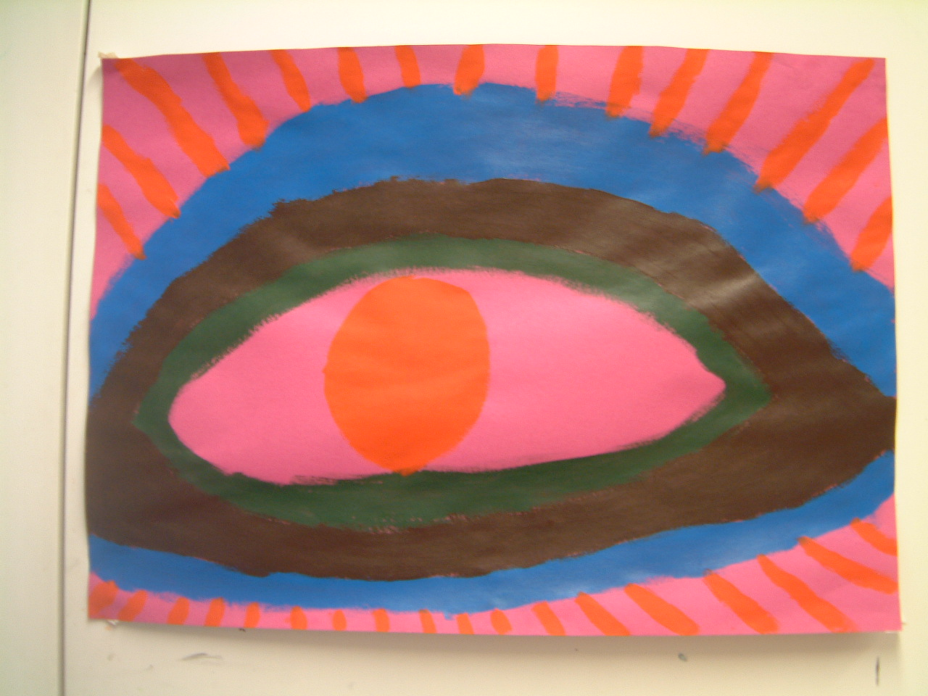
Figure 3
The eye, the client said, had seen something terrible. So by looking at the eye we were looking at both the horror and how the horror might affect a person who saw it. The image was a pivot between the horror, a person witnessing that horror, she who looked at the eye that she had made and I who looked at her and at the eye. The terrible thing is literally part of the person witnessing it. She wasn’t inviting me to look at the horror, but at her as affected by the horror – it commented on my role and our relationship, about involvement and detachment that related to her witnessing the terrible thing and my witnessing of her and the terrible thing.

This image seems to me to set up a perspective in relation to the reasons the woman was in therapy – to help her integrate her past traumatic experiences, and illustrates an intersubjective relationship between patient, therapist, world and image. No other words beside her explanation seemed necessary at this point. A focus on the image itself either in how it was made or any other aspect of the image would not have taken us any further either. The therapeutic work was in her experience of making it and in mine of being with her watching her make it and seeing it finished. In other words the therapy was not in the image directly, or the talk but in something that happened within the boundaried space in art therapy between words and images experienced in a relationship. Performance then acts as some sort of hinge between words and images, between imagination and the sensory. This is not to say that in understanding the image in another context such as supervision or in theory writing we might look at the way the space in the image has been used, the colour and the paint laid on. This would be another performance towards meaning making.

Conclusion
In this critique of David Mann’s and David Maclagan’s papers I have tried to show that amongst the important ideas for art therapy there are contradictions, which throw art therapy back on a status quo which endangers it. I have argued that this happens because of a neglect of a consideration of embodiment and thus context, gender and perceptual experience. The relationship of logical discourse to art in art therapy risks subjugating art’s potency and of swallowing it up into ideologies which promulgate the status quo: splits between mind and body, health and illness, sanity and madness. Within the profession of art therapy splits are expressed in the couplets ‘art therapy’ and ‘art psychotherapy’; ‘art therapy’ and ‘the arts in health’; ‘group analytic art therapy’ and ‘studio-based art therapy’. The way forward must be to deconstruct the binaries rather than opt for one or the other.

In these times in which ‘talking’ therapies have become the favoured treatment for mental ill health, it is vital that we have a strong theory which promotes what it is we do in particular, and how it can help people with the problems for which they need therapy. It is important that we can articulate, in the dominant language of logic, the intersubjective relationship between imagination, the perceptual, interpersonal relationships, the manifest symptom, images and the boundaried art therapeutic, performance space.

References

Dalley T, Rifkind G, Terry K ‘Three voices of art therapy: image, client, therapist’ Routledge London and New York

Derrida J (1997) ‘Of Grammatology’ transl. Spivak G.C. The John Hopkins University Press Baltimore and London. Originally published as ‘De La Grammatologie 1967 Les Editions de Minuit, France

Derrida J (1988) ‘Limited Inc’. Samuel Weber and Jeffrey Mehlman (trans.), Gerald Graff (ed.) Evanston: North Western University Press

Eagleton T (2003) ‘After Theory’ Allen Lane an imprint of Penguin Books, London

Irigaray L (2004) ‘Key Writings’ continuum London and New York
Maclagan, D. (1995) ‘Fantasy and the Aesthetic: Have they become the Uninvited guests at Art Therapy’s feast?’ Arts in Psychotherapy 22 (3): 217-221
Maclagan, D. (2001) ‘Psychological Aesthetics: Painting, Feeling and Making Sense’, London and Philadelphia: Jessica Kingsley

Maclagan D (2005) ‘Re-Imagining Art Therapy’ International Journal of Art Therapy: Inscape vol.10 no1 June 2005

Mann D (2006) ‘Art therapy: Re-imagining a psychoanalytic perspective – A reply to David Maclagan International Journal of Art Therapy: Inscape vol.11 no 1. June 2006

McNeilly G (2006) ‘Group Analytic Art Therapy’ Jessica Kingsley Publishers, London and New York

Melville S (1998) ‘The Temptation of New Perspectives’ in ‘The Art of Art History: A Critical Anthology ed. Preziosi D Oxford University Press

Schaverien J. (2000) ‘The Triangular Relationship and the Aesthetic Countertransference in Analytical Art Psychotherapy’ in ‘The Changing Shape of Art Therapy. New Developments in Theory and Practice’ eds Gilroy A and McNeilly G, Jessica Kingsley Publishers, London and Philadelpia.
Skaife 2001 ‘Making visible: art therapy and Intersubjectivity’ Inscape vol 6 no 2

Waller D and Dalley T. (1992) ‘Art Therapy; a theoretical perspective’ in Waller D, and Gilroy A, eds (1992) ‘Art Therapy: a Handbook’ Oxford Universities Press

Irigaray provides evidence for her assertion of differences between men and women and for the need to promote female experience. Her research ( ) on writers reveals that men make more use of logical language and women figurative language with patriarchy resulting in the dominance of logical language. One could understand the privileging of the cerebral in the writing of Maclagan and Mann, as with their father figures Jung and Freud, to be to do with male experience which is proposed as applying equally to women.

'David Maclagan, of all art therapy theorists, is renowned for promoting the embodied nature of aesthetic response, for example, in his book 'Psychological Aesthetics' (2001) and Inscape (1995). This article, as a deconstruction, is an argument with a text not with the thinking or clinical practice for that matter, of either author.'

